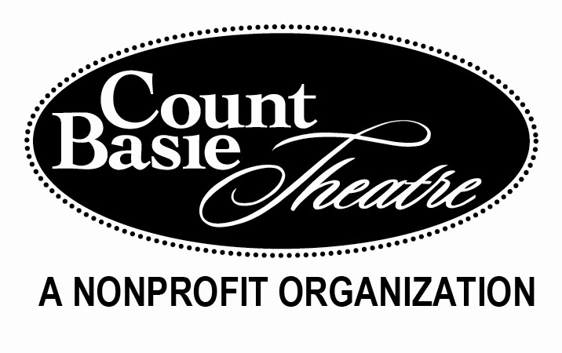

Arts Impact Scholarships

Applicant must attend a Monmouth County High School, graduating during the 2017-2018 school year, and be no older than 19 years of age.
To qualify for the Monmouth County Freeholders’ Basie Scholarship for Continuing Education, applicant must be attending a college located in New Jersey in the fall.

Applicant Information: Complete all fields legibly.
Name
Street Address
City ST ZIP Code
Home Phone
Cell Phone
E-Mail Address
Parent / Guardian
Parent / Guardian

School Information
High School
Address
Contact
Phone / Email

College I Plan to Attend in the Fall of 2018
College
Address
Admissions contact
Phone / Email

If unknown, provide colleges you have applied to:
College:
College
College
College:
College
College

Page: 2 Applicant’s Name: ____________________________________________________

References should be the same as those submitting letters of recommendation

Reference 1
Name
Street Address
City State ZIP Code
Home Phone
Work Phone
E-Mail Address
Relationship to Applicant

Reference 2
Name
Street Address
City State ZIP Code
Home Phone
Work Phone
E-Mail Address
Relationship to Applicant

Reference 3
Name
Street Address
City State ZIP Code
Home Phone
Work Phone
E-Mail Address
Relationship to Applicant

Application Checklist
Return this application along with the following documents

Personal Resume Personal Info Form: Letters of Recommendation 1

Essay

Deadline: April 6, 2018 at 4:00 pm
Count Basie Theatre
Arts Impact Scholarships
99 Monmouth Street
Red Bank, NJ 07701

